**OUTBOUND Payment Document**

Merchant Development Department

**Version Control**

|  |  |  |  |  |
| --- | --- | --- | --- | --- |
| **Document Statues** | **Document Name** | **Outbound Payment** | **Confidentiality level** | **Restricted** |
| Draft | **Author** | **Ni Shenzhou** | **Completion date** | **June 5, 2022** |
| Revised Version | **Reviewed by** |  | **Last review date** |  |
| Officially released | **Approved by** | **Wenbo Tang** | **Last approval date** |  |

**Revision History**

|  |  |  |  |
| --- | --- | --- | --- |
| **Versions** | **Revision Date** | **Revised content** | **Revisionist** |
| **1.3** | **2022/07/25** | 1. **Add applyStatus field to all responses** 2. **Add applyStatus value list** 3. **Remove 100-200 value from responseCode list** 4. **Add deviceId field(Required) to all responses(except notification response) and notification request .** 5. **Add deviceId field(Optional) to all request(except notification request).** | **Yue Shen** |
| **1.2.5** | **2022/07/22** | 1. **Add the originalMisOrderNo field to the query order response** 2. **Add cardOrganization available value list** 3. **Add error code 114** | **Yue Shen** |
| **1.2.4** | **2022/07/18** | 1. **Remove request isEmvTag parameter, response will contain emvTag when the order has emvTag** 2. **Change emvTag field name Aid to aid** | **Yue Shen** |
| **1.2.3** | **2022/07/15** | 1. **Add responseCode, 112,113,201,202** 2. **Correct notification variable name, swapped requestTime and responseTime .** | **Yue Shen** |
| **1.2.2** | **2022/07/11** | 1. **Improve document content** | **Yue Shen** |
| **1.2.1** | **2022/07/11** | 1. **Change the parameter tipsAmount to tipAmount** 2. **The currency of all amounts is AED** | **Yue Shen** |
| **1.2** | **2022/07/10** | 1. **Change chapter’s name** 2. **Make MisOrderNo uniqueness** 3. **Add responseCode value definition (201,202)** 4. **Update Sale and Void interaction diagram** 5. **Add merchantOrderNo parameter** | **Yue Shen** |
| **1.1.4** | **2022/07/05** | **Add connection heartbeat detection api** | **Ni Shenzhou** |
| **1.1.3** | **2022/06/01** | **Improve document structure** | **Yue Shen** |
| **1.1.2** | **2022/06/01** | **Bank card transactions add TC and card type fields return** | **Ni Shenzhou** |
| **1.1.1** | **2022/05/18** | **Add payment transaction interface** | **Ni Shenzhou** |

**Contents**

[1. Introduction 4](#_Toc109721513)

[2. Terms and Definitions 5](#_Toc109721514)

[messageType 5](#_Toc109721515)

[requestTime 5](#_Toc109721516)

[messageId 5](#_Toc109721517)

[functionName 5](#_Toc109721518)

[applyStatus 5](#_Toc109721519)

[amount 5](#_Toc109721520)

[misOrderNo 5](#_Toc109721521)

[payMethod 5](#_Toc109721522)

[printReceiptType 5](#_Toc109721523)

[EMVTag 5](#_Toc109721524)

[voucherNo 6](#_Toc109721525)

[referenceNo 6](#_Toc109721526)

[authorizationNo 6](#_Toc109721527)

[cardType 6](#_Toc109721528)

[responseTime 6](#_Toc109721529)

[merchantOrderNo 6](#_Toc109721530)

[responseCode 6](#_Toc109721531)

[3. Fast Integration 8](#_Toc109721532)

[3.1. Resource Introduction 8](#_Toc109721533)

[3.2. Quick call example 8](#_Toc109721534)

[4. Trading 10](#_Toc109721535)

[4.1. Sale 10](#_Toc109721536)

[4.2. Void 13](#_Toc109721537)

[4.3. Querying orders 16](#_Toc109721538)

[4.4. Sale transaction notification 18](#_Toc109721539)

[4.5. Send heartbeat 21](#_Toc109721540)

[5. Appendix 23](#_Toc109721541)

[5.1. Apply status code 23](#_Toc109721542)

# Introduction

# Terms and Definitions

##### messageType

Message types. Divided into Request and Response messages, each request should have a response, and they are associated through messageId.

|  |
| --- |
| **messageType value** |
| Request |
| Response |

##### requestTime

unix epoch time milliseconds

##### messageId

The messageId of the request and the messageId of the response are identical and are used to match the request and the response. The recipient of the request should copy the messageId of the request into the response as-is.

##### **functionName**

Used for function routing, the receiver classifies the requests according to functionName.

##### applyStatus

When the client receives the response of the ecr, it should check the applyStatus field first. If applyStatus = 0, it means that the request was processed correctly, and then read other fields. When applyStatus !=0, it means that this request has failed, and you don't need to read other fields, because the values of other fields are meaningless at this time.

##### amount

The currency of all amounts is AED by default

##### misOrderNo

mis order number, is unique within a device, the same order number can be sent repeatedly.

##### payMethod

Payment methods. The available options are.

|  |  |
| --- | --- |
| **messageType value** | **Description** |
| PAYBY | PAYBY Wallet Payment |
| BOTIM | BOTIM Wallet Payment |
| BANK\_CARD | Bank Card Payment |

##### printReceiptType

Receipt to be printed

|  |  |
| --- | --- |
| **messageType value** | **Description** |
| 0 | no receipts printed (default) |
| 1 | Print customer receipt |
| 2 | Print merchant receipt |
| 3 | Print customer receipts and merchant receipt |

##### EMVTag

Related data is generated by the EVM kernel during bank card transactions.

|  |  |  |
| --- | --- | --- |
| **Field Name** | **Type** | **Description** |
| **aid** | String | Application Identifier |
| **atc** | String | Application Transaction Counter |
| **tsi** | String | Transaction Status Information |
| **tvr** | String | Terminal verification results |
| **cid** | String | Cryptographic information data |
| **arqc** | String | Application Cipher AC |
| **arpc** | String |  |
| **tc** | String |  |
| **appName** | String | Application Name |
| **appLabel** | String | Application Tags |

##### voucherNo

Streaming number, server or POSP system tracking number. Generated by the terminal and sent to the server, usually placed in the ISO8583 11 domain.

##### referenceNo

Reference number RRN. generated by the payment system and returned to the terminal, usually placed in the ISO 8583 37 field.

##### authorizationNo

Authorization number. Generated by the payment system and returned to the terminal, usually placed in the ISO 8583 38 field.

##### cardType

The type of card used for bank card transactions.

|  |  |
| --- | --- |
| **messageType value** | **Description** |
| Magnetic Stripe | Magnetic Stripe Card Transaction |
| Contactless | card waving/contactless transaction |
| Contact | Card Insert/Contact Card Transaction |
| Manual | Manual card number entry transaction |

**cardOrganization**

|  |
| --- |
| **cardOrganization** |
| VISA |
| MASTERCARD |

##### responseTime

unix epoch time milliseconds

##### merchantOrderNo

Merchant order number, the order number generated by the pos machine, which is unique within a merchant system

##### responseCode

|  |  |
| --- | --- |
| **Value** | **Description** |
| **00** | Order is success |
| **201** | Order is processing |
| **202** | Order is failure |
| **01-99** | Order is failure, value is the reason of the failure |

# Fast Integration

## Resource Introduction

Copy the obtained aar file to the libs folder of the corresponding module (if there is no such directory, create a new one), and then add the following code to the build.gradle file.

|  |
| --- |
| android {  repositories {  flatDir { dirs 'libs' }  }  }  dependencies {  implementation (name: 'payby-export-payment-xxx', ext: 'aar')  } |
|  |

After the import of aar is complete, rebuild the project.

## Quick call example

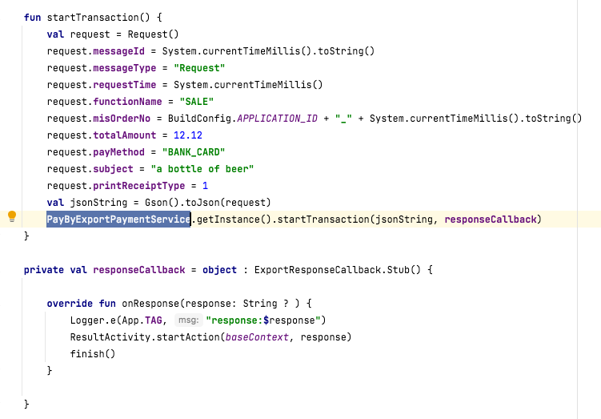

For more usage examples, please refer to the demo

**!!! Attention**

When a Request type message is received, a Response type message needs to be sent to the PayBy payment application.

l  **Sample request**

|  |
| --- |
| {  "messageType": "Request",  "messageId": "123456",  "functionName": "SALE",           "requestTime": 1581404947666,           "misOrderNo": "M965739182419",           "subject": "Your subject",  } |

# Trading

## Sale

The merchant app initiates a sale request to payby pos, the pos machine responds immediately and opens ui, accepts the user's swipe card, then submits the online transaction and receives the connection transaction result and notifies the merchant app. if the merchant app does not receive a response, it can initiate the query result itself.

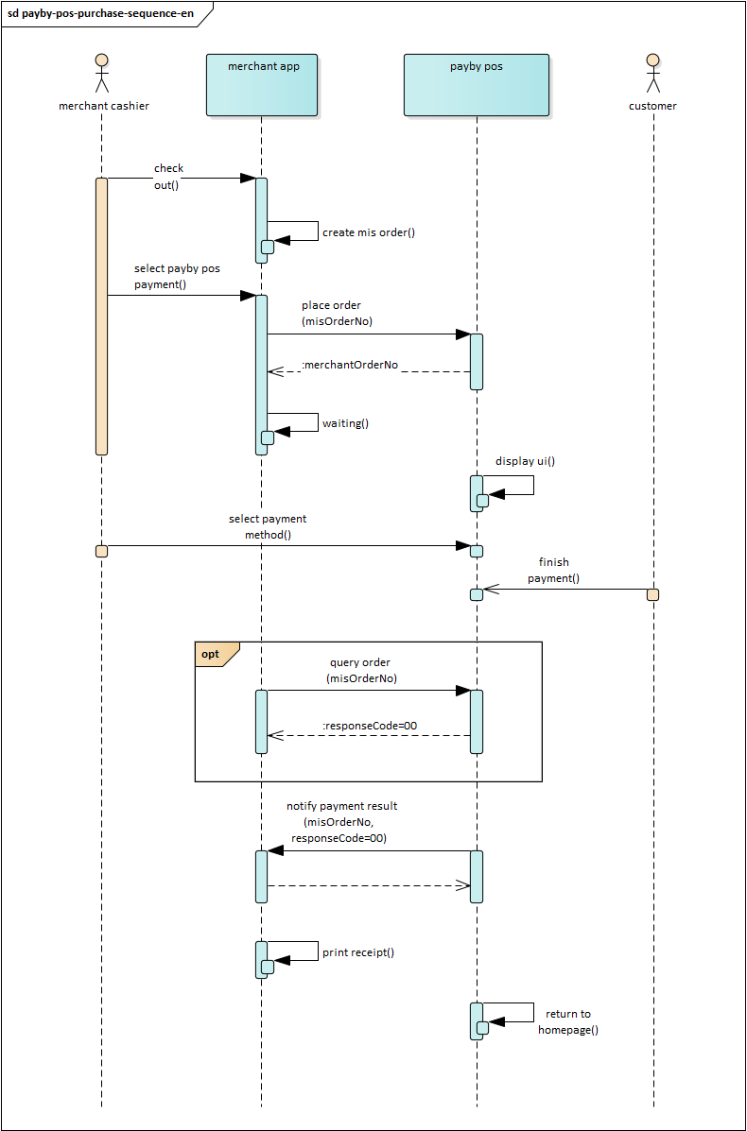

l  **Request Parameters**

|  |  |  |  |
| --- | --- | --- | --- |
| **Field Name** | **Type** | **Is mandatory** | **Description** |
| **requestTime** | Number | M | Request Time |
| **messageType** | String | M | Message type. Request |
| **functionName** | String | M | The name of the requested API. SALE |
| **messageId** | String | M | Unique identification of the message |
| **misOrderNo** | String | M | mis Order number |
| **subject** | String | M | Product Name |
| **totalAmount** | Number | M | The total amount of the order (in dollars). Example: 12.00 |
| **tipAmount** | Number | O | Tip amount |
| **payMethod** | String | O | Payment Method |
| **printReceiptType** | Number | O | Print Receipt Method. |
| **deviceId** | Number | O | device number assigned by payby |

l  **Sample request**

|  |
| --- |
| {         "messageType": "Request",         "functionName": "SALE",         "requestTime": 1581404947666,         "messageId": "KX121313124144141",         "misOrderNo": "M965739182419",         "subject": "Your subject",         "totalAmount": 12.00,         "tipAmount": 1.00,         "payMethod": "BANK\_CARD",         "printReceiptType": 3,       "deviceId": "123555"  } |

l  **Response parameters**

|  |  |  |  |
| --- | --- | --- | --- |
| **Field Name** | **Type** | **Is mandatory** | **Description** |
| **applyStatus** | Number | M | Check applyStatus first |
| **responseTime** | Number | M | Response time, unix epoch time milliseconds. |
| **responseCode** | String | M | Response Code |
| **responseMessage** | String | O | Response Description |
| **messageType** | String | M | Message type. response |
| **functionName** | String | M | The name of the requested API. SALE |
| **messageId** | String | M | Unique identification of the message |
| **misOrderNo** | String | M | mis order number |
| **subject** | String | O | Product Name |
| **totalAmount** | Number | M | Total order amount |
| **tipAmount** | Number | O | Spending tip amount |
| **payMethod** | String | O | Payment Method |
| **appVersion** | String | M | Application version number |
| **packageName** | String | M | Application Package Name |
| **merchantName** | String | O | Merchant Name |
| **merchantNo** | String | O | Merchant Number |
| **merchantOrderNo** | String | M | Merchant order number, generated by the pos machine, which is unique within a merchant system |
| **terminalNo** | String | O | Terminal number |
| **deviceId** | Number | M | device number assigned by payby |

l  **Sample response**

|  |
| --- |
| {  "applyStatus": 0,         "responseTime": 1581404947666,         "responseCode": "201",         "responseMessage": "Success",         "messageType": "Response",         "functionName": "SALE",         "messageId": "KX121313124144141",         "misOrderNo": "M965739182419",         "subject": "Your subject",         "totalAmount": 12.00,         "tipAmount": 1.00,         "payMethod": "BANK\_CARD",         "appVersion": "1.2.121",         "packageName": "com.payby.pos",         "merchantName": "Shanghai Tavern",         "merchantNo": "5131631641641",         "merchantOrderNo": "05c97402-8f80-4423-af9d-53cd675a3a54",         "terminalNo": "1453151",         "deviceId": "123555"  } |
|  |

## Void

Merchant app initiates VOID request to payby pos, pos machine submits online transaction and receives connection transaction result and returns to merchant app synchronously. if merchant app does not receive response, it can initiate query result by itself.

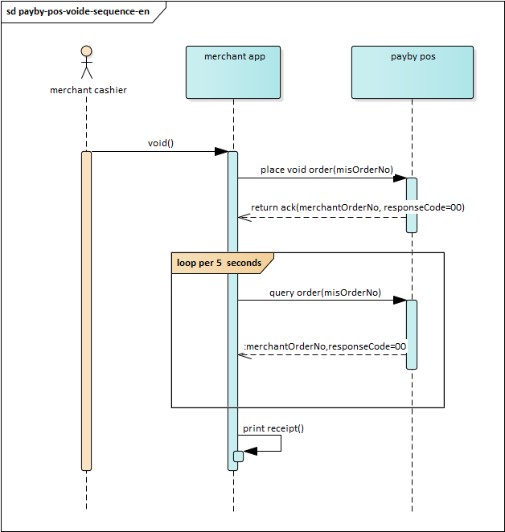

l  **Request Parameters**

|  |  |  |  |
| --- | --- | --- | --- |
| **Field Name** | **Type** | **Is mandatory** | **Description** |
| **requestTime** | Number | M |  |
| **messageType** | String | M | Request |
| **functionName** | String | M | VOID |
| **messageId** | String | M |  |
| **misOrderNo** | String | M |  |
| **originalMisOrderNo** | String | M | Original transaction mis order number |
| **printReceiptType** | Number | O |  |
| **deviceId** | Number | O | device number assigned by payby |

l  **Sample request**

|  |
| --- |
| {         "messageType": "Request",         "functionName": "VOID",         "requestTime": 1581404947666,         "messageId": "KX121313124144141",         "misOrderNo": "M965739182419",         "originalMisOrderNo": "M965739182419",         "printReceiptType": 3,      "deviceId": "123555"  } |

**Response parameters**

|  |  |  |  |
| --- | --- | --- | --- |
| **Field Name** | **Type** | **Is mandatory** | **Description** |
| **applyStatus** | Number | M | Check applyStatus first |
| **responseTime** | Number | M | Response time, unix epoch time milliseconds. |
| **responseCode** | String | M | Response Code |
| **responseMessage** | String | O | Response Description |
| **messageType** | String | M | Message type. response |
| **functionName** | String | M | The name of the requested API. VOID |
| **messageId** | String | M | Unique identification of the message |
| **misOrderNo** | String | M | mis order number |
| **originalMisOrderNo** | String | M | Original mis order number |
| **subject** | String | O | Product Name |
| **totalAmount** | Number | M | Total order amount |
| **tipAmount** | Number | O | Spending amount |
| **payMethod** | String | O | Payment Method |
| **appVersion** | String | M | Application version number |
| **packageName** | String | M | Application Package Name |
| **merchantName** | String | O | Merchant Name |
| **merchantNo** | String | O | Merchant Number |
| **merchantOrderNo** | String | M | This is merchantOrderNo used by void. |
| **terminalNo** | String | O | Terminal number |
| **deviceId** | Number | M | device number assigned by payby |
| **emvTag** | EmvTag | O | Some of the EMV data in the transaction. Reference [EmvTag](file:///C:\\Users\\sy\\Desktop\\PAYBY%20ECR%20%E6%94%AF%E4%BB%98%E6%96%87%E6%A1%A3_1.1.2_20220602%20-px%20en-US.htm" \l "_5.5_EmvTag) |

l  **Sample response**

|  |
| --- |
| {  "applyStatus": 0,         "responseTime": 1581404947666,         "responseCode": "201",         "responseMessage": "Success",         "messageType": "Response",         "functionName": "VOID",         "messageId": "KX121313124144141",         "misOrderNo": "M965739182419",         "originalMisOrderNo": "M965739182418",         "subject": "Your subject",         "totalAmount": 12.00,         "tipAmount": 1.00,         "payMethod": "BANK\_CARD",         "appVersion": "1.2.121",         "packageName": "com.payby.pos",         "merchantName": "Shanghai Tavern",         "merchantNo": "5131631641641",         "merchantOrderNo": "05c97402-8f80-4423-af9d-53cd675a3a54",         "terminalNo": "1453151",      "deviceId": "123555",       "emvTag": {           "aid": "A0000000333",           "atc": "892311",           "tsi": "8000",           "tvr": "0000000000",           "cid": "921303",           "tc": "012131314142141231",           "arqc": "983112345678",           "arpc": "983112345678",           "appName": "Visa Debit",           "appLabel": "Visa"       }  } |
|  |

## Querying orders

This interface provides the query of all orders. Merchants can actively query the order status through the query order interface to complete the next step of business logic. Cases where the query interface needs to be called.

1. When there is an abnormality in the merchant's backend, network, server, etc. The merchant's system eventually does not receive the payment notification.

2. After calling the payment interface, a system error or unknown transaction status situation is returned.

l  **Request Parameters**

|  |  |  |  |
| --- | --- | --- | --- |
| **Field Name** | **Type** | **Is mandatory** | **Description** |
| **requestTime** | Number | M |  |
| **messageType** | String | M | Request |
| **functionName** | String | M | GET\_ORDER |
| **messageId** | String | M |  |
| **misOrderNo** | String | M |  |
| **transactionType** | String | M | SALE,VOID |
| **deviceId** | Number | O | device number assigned by payby |

l  **Sample request**

|  |
| --- |
| {         "messageType": "Request",         "functionName": "GET\_ORDER",         "transactionType": "SALE",         "requestTime": 1581404947666,         "messageId": "KX121313124144141",         "misOrderNo": "M965739182419",      "deviceId": "123555"  } |

l  **Response parameters**

|  |  |  |  |
| --- | --- | --- | --- |
| **Field Name** | **Type** | **Is mandatory** | **Description** |
| **applyStatus** | Number | M | Check applyStatus first |
| **responseTime** | Number | M | Response time |
| **responseCode** | String | M | Response Code |
| **responseMessage** | String | M | Response Description |
| **messageType** | String | M | Response |
| **functionName** | String | M | GET\_ORDER |
| **transactionType** | String | M | Transaction type. SALE |
| **messageId** | String | M | Unique identification of the message |
| **misOrderNo** | String | M | mis order number |
| **originalMisOrderNo** | String | O | When the transactionType is SALE, this field is empty.When the transactionType is VOID, this field is mandatory and is to indicate the order to be voided. |
| **orderNo** | String | M | PayBy System Order Number |
| **subject** | String | M | Product Name |
| **totalAmount** | Number | M | Total order amount |
| **tipAmount** | Number | O | Spending amount |
| **payMethod** | String | O | Payment Method |
| **appVersion** | String | M | Application version number |
| **packageName** | String | M | Application Package Name |
| **merchantName** | String | M | Merchant Name |
| **merchantNo** | String | M | Merchant Number |
| **merchantOrderNo** | String | M | Merchant order number, generated by the pos machine, which is unique within a merchant system |
| **terminalNo** | String | O | Terminal number |
| **deviceId** | Number | M | device number assigned by payby |
| **cardType** | String | O | Card type. For example: Contact |
| **cardOrganization** | String | O | card organizations. For example: VISA |
| **cardNoMask** | String | O | Card number mask. For example: 123456 \*\*\*\*0888 |
| **cardHolderName** | String | O | Cardholder Name |
| **voucherNo** | String | O | System trace audit number (STAN) |
| **referenceNo** | String | O | Reference number |
| **authorizationNo** | String | O | Authorization Number |
| **transactionDate** | String | O | Transaction Date |
| **transactionTime** | String | O | Trading Hours |
| **emvTag** | EmvTag | O | Some of the EMV data in the transaction. Reference [EmvTag](file:///C:\\Users\\sy\\Desktop\\PAYBY%20ECR%20%E6%94%AF%E4%BB%98%E6%96%87%E6%A1%A3_1.1.2_20220602%20-px%20en-US.htm" \l "_5.5_EmvTag) |

l  **Sample response**

|  |
| --- |
| {  "applyStatus": 0,      "responseTime": 1581404947666,      "responseCode": "00",  "responseMessage": "Success",      "messageType": "Response",      "functionName": "GET\_ORDER",      "transactionType": "SALE",      "messageId": "KX121313124144141",  "misOrderNo": "M965739182419",  "originalMisOrderNo": "M965739182418",      "orderNo": "1234567",      "subject": "Your subject",      "totalAmount": 12,      "tipAmount": 1,      "payMethod": "BANK\_CARD",      "appVersion": "1.2.121",      "packageName": "com.payby.pos",  "merchantName": "Shanghai Tavern",   "merchantOrderNo": "05c97402-8f80-4423-af9d-53cd675a3a54",      "merchantNo": "5131631641641",      "terminalNo": "1453151",      "deviceId": "123555",      "cardType": "Contactless",      "cardOrganization": "VISA",      "cardNoMask": "123456\*\*\*\*\*\*\*\*\*\*\*0008",      "cardHolderName": "AAA BBBS",      "voucherNo": "123456",      "transactionTime": "1010",      "transactionDate": "0510",      "referenceNo": "123456",      "authorizationNo": "12345678",      "emvTag": {          "aid": "A0000000333",          "atc": "892311",          "tsi": "8000",          "tvr": "0000000000",          "cid": "921303",          "tc": "012131314142141231",          "arqc": "983112345678",          "arpc": "983112345678",          "appName": "Visa Debit",          "appLabel": "Visa"      }  } |
|  |

## Sale transaction notification

The pos will notify the SALE transaction result to the mis, and the mis side needs to send a response message to the pos after receiving the notification. If the pos does not receive the response, a message notification will be sent every 5 seconds and repeated 3 times.

If the mis system handles the notification correctly, it should return applyStatus=0, and pos will not send further notifications. If the mis system cannot handle the notification properly, it should return applyStatus=105 and pos will send the message again (up to 3 times).

l  **Notification parameters**

|  |  |  |  |
| --- | --- | --- | --- |
| **Field Name** | **Type** | **Is mandatory** | **Description** |
| requestTime | Number | M | request time |
| **responseCode** | String | M | Response Code |
| **responseMessage** | String | M | Response Description |
| **messageType** | String | M | Request |
| **functionName** | String | M | NOTIFY\_ORDER |
| **transactionType** | String | M | Transaction type. SALE |
| **messageId** | String | M | Unique identification of the message |
| **misOrderNo** | String | M | mis order number |
| **orderNo** | String | M | PayBy System Order Number |
| **subject** | String | M | Product Name |
| **totalAmount** | Number | M | Total order amount |
| **tipAmount** | Number | O | Spending amount |
| **payMethod** | String | O | Payment Method |
| **appVersion** | String | M | Application version number |
| **packageName** | String | M | Application Package Name |
| **merchantName** | String | M | Merchant Name |
| **merchantNo** | String | M | Merchant Number |
| **merchantOrderNo** | String | M | Merchant order number, generated by the pos machine, which is unique within a merchant system |
| **terminalNo** | String | O | Terminal number |
| **deviceId** | Number | M | device number assigned by payby |
| **cardType** | String | O | Card type. For example: Contact |
| **cardOrganization** | String | O | card organizations. For example: VISA |
| **cardNoMask** | String | O | Card number mask. For example: 123456 \*\*\*\*0888 |
| **cardHolderName** | String | O | Cardholder Name |
| **voucherNo** | String | O | System trace audit number (STAN) |
| **referenceNo** | String | O | Reference number |
| **authorizationNo** | String | O | Authorization Number |
| **transactionDate** | String | O | Transaction Date |
| **transactionTime** | String | O | Trading Hours |
| **emvTag** | EmvTag | O | Some of the EMV data in the transaction. Reference [EmvTag](file:///C:\\Users\\sy\\Desktop\\PAYBY%20ECR%20%E6%94%AF%E4%BB%98%E6%96%87%E6%A1%A3_1.1.2_20220602%20-px%20en-US.htm" \l "_5.5_EmvTag) |

l

l  **Sample notification**

|  |
| --- |
| {      "requestTime": 1581404947666,      "responseCode": "00",  "responseMessage": "Success",         "messageType": "Request",         "functionName": "NOTIFY\_ORDER",      "transactionType": "SALE",      "messageId": "KX121313124144141",      "misOrderNo": "M965739182419",      "orderNo": "1234567",      "subject": "Your subject",      "totalAmount": 12,      "tipAmount": 1,      "payMethod": "BANK\_CARD",      "appVersion": "1.2.121",      "packageName": "com.payby.pos",      "merchantName": "Shanghai Tavern",  "merchantNo": "5131631641641",   "merchantOrderNo": "05c97402-8f80-4423-af9d-53cd675a3a54",      "terminalNo": "1453151",      "deviceId": "123555",      "cardType": "Contactless",      "cardOrganization": "VISA",      "cardNoMask": "123456\*\*\*\*\*\*\*\*\*\*\*0008",      "cardHolderName": "AAA BBBS",      "voucherNo": "123456",      "transactionTime": "1010",      "transactionDate": "0510",      "referenceNo": "123456",      "authorizationNo": "12345678",      "emvTag": {          "aid": "A0000000333",          "atc": "892311",          "tsi": "8000",          "tvr": "0000000000",          "cid": "921303",          "tc": "012131314142141231",          "arqc": "983112345678",          "arpc": "983112345678",          "appName": "Visa Debit",          "appLabel": "Visa"      }  } |

l  **Response parameters**

|  |  |  |  |
| --- | --- | --- | --- |
| **Field Name** | **Type** | **Is mandatory** | **Description** |
| **applyStatus** | Number | M | If the mis system handles the notification correctly, it should return applyStatus=0, and pos will not send further notifications.  If the mis system cannot handle the notification properly, it should return applyStatus=105 and pos will send the message again (up to 3 times). |
| **responseTime** | Number | M |  |
| **messageType** | String | M | Response |
| **functionName** | String | M | NOTIFY\_ORDER |
| **messageId** | String | M | MessageId of the original notification |
| **misOrderNo** | String | M | misOrderNo of the notification |

l  **Sample response**

|  |
| --- |
| {         "messageType": "Response",         "functionName": "NOTIFY\_ORDER",         "responseTime": 1581404947666,         "messageId": "KX121313124144141",         "misOrderNo": "M965739182419",  "response": “SUCCESS”,  } |

## Send heartbeat

When you use websocket as a connection method, you need to send a heartbeat periodically to check the validity of the connection. When you do not receive the correct heartbeat back, you need to assume that the connection has failed and need to re-establish the connection immediately.

l  **Request Parameters**

|  |  |  |  |
| --- | --- | --- | --- |
| **Field Name** | **Type** | **Is mandatory** | **Description** |
| **requestTime** | Number | M |  |
| **messageType** | String | M | Request |
| **functionName** | String | M | TERMINAL\_HEARTBEAT\_CHECK |
| **messageId** | String | M |  |
| **deviceId** | Number | O | device number assigned by payby |

l  **Sample request**

|  |
| --- |
| {         "messageType": "Request",         "functionName": "TERMINAL\_HEARTBRAT\_CHECK",         "requestTime": 1581404947666,         "messageId": "KX121313124144141",      "deviceId": "123555"  } |

l  **Response parameters**

|  |  |  |  |
| --- | --- | --- | --- |
| **Field Name** | **Type** | **Is mandatory** | **Description** |
| **applyStatus** | Number | M | Check applyStatus first |
| **responseTime** | Number | M |  |
| **messageType** | String | M | Response |
| **functionName** | String | M | TERMINAL\_HEARTBEAT\_CHECK |
| **messageId** | String | M |  |
| **deviceId** | Number | M | device number assigned by payby |

l  **Sample response**

|  |
| --- |
| {  "applyStatus": 0,         "messageType": "Response",         "functionName": " TERMINAL\_HEARTBRAT\_CHECK ",         "responseTime": 1581404947666,         "messageId": "KX121313124144141",       "deviceId": "123555"  } |

# Appendix

## Apply status code

|  |  |
| --- | --- |
| **Value** | **Description** |
| **0** | The request was processed correctly |
| **101** | Parameter error |
| **104** | Too frequent requests |
| **105** | System Error |
| **106** | Service Timeout |
| **107** | Risk control verification failure |
| **109** | Product not applied |
| **110** | Merchant equipment does not exist |
| **111** | Device Access Denied |
| **112** | Requests with the same order number cannot be sent repeatedly. Use query order function to get the order status |
| **113** | The pos machine is processing other session. |
| **114** | The pos machine is executing another query request. |